Bulk Edit Start Guide V1.0
Jodean Hendrie
May 17, 2024
TABLE OF CONTENTS

1) Introduction 2
2) Estate Account tab and Bulk Edit 2
3) Bulk Edit Transaction Window 4
a) All input fields excluding re-categorization. 4
b) Re-categorize Transactions. 5

Introduction

Introducing Bulk Edit. Bulk edit will allow you to edit various items across multiple transactions with the same update.

The following fields can be bulk edited:
- Account
- Date of Transaction
- Transaction Name
- Account Type
- Notes
- Exclude from executor compensation.

You also can also re-categorize transactions in bulk see section 3 b.

Note: only certain transaction types can be bulk edited. Restricted categories, transactions within a locked accounting period and transaction linked to an inventory item cannot be bulk edited.

Estate Account tab and Bulk Edit

You can bulk edit two to many transactions from the Estate Accounting tab as follows:

- Click Bulk Editable Transactions checkbox.
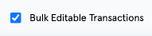

- You will receive the following modal message indicating that Restricted Categories have been removed. NOTE: Restricted categories include locked account items, and items linked to inventory as they cannot be bulk edited. Click OK to proceed.
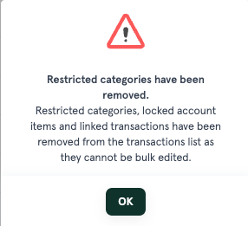

- All the restricted categories will be removed, and you will be presented with a list of items that can be bulk edited. Note: Use the Filter By: options to further reduce the list. i.e. Filter by account, categories, revenue, capital, investment and Other.

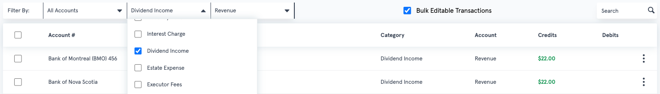

- Check each transaction to be bulk edited (individually or check all). Note: only select items that will have the same edit across each transaction.

- Click Bulk Edit to proceed.

- The Bottom Ribbon has the following additional functionality:

  - If you click on the X in the bottom left corner, all items will be unchecked.
  - The number of items selected.
  - You also have the ability to Delete the selected items. Note: If you click delete your will, be presented with a modal message as follows: You are about to delete 21 transactions permanently. This cannot be undone. Are you sure? If you click Cancel you will return to the previous window. If you click Delete, your items will be permanently deleted.

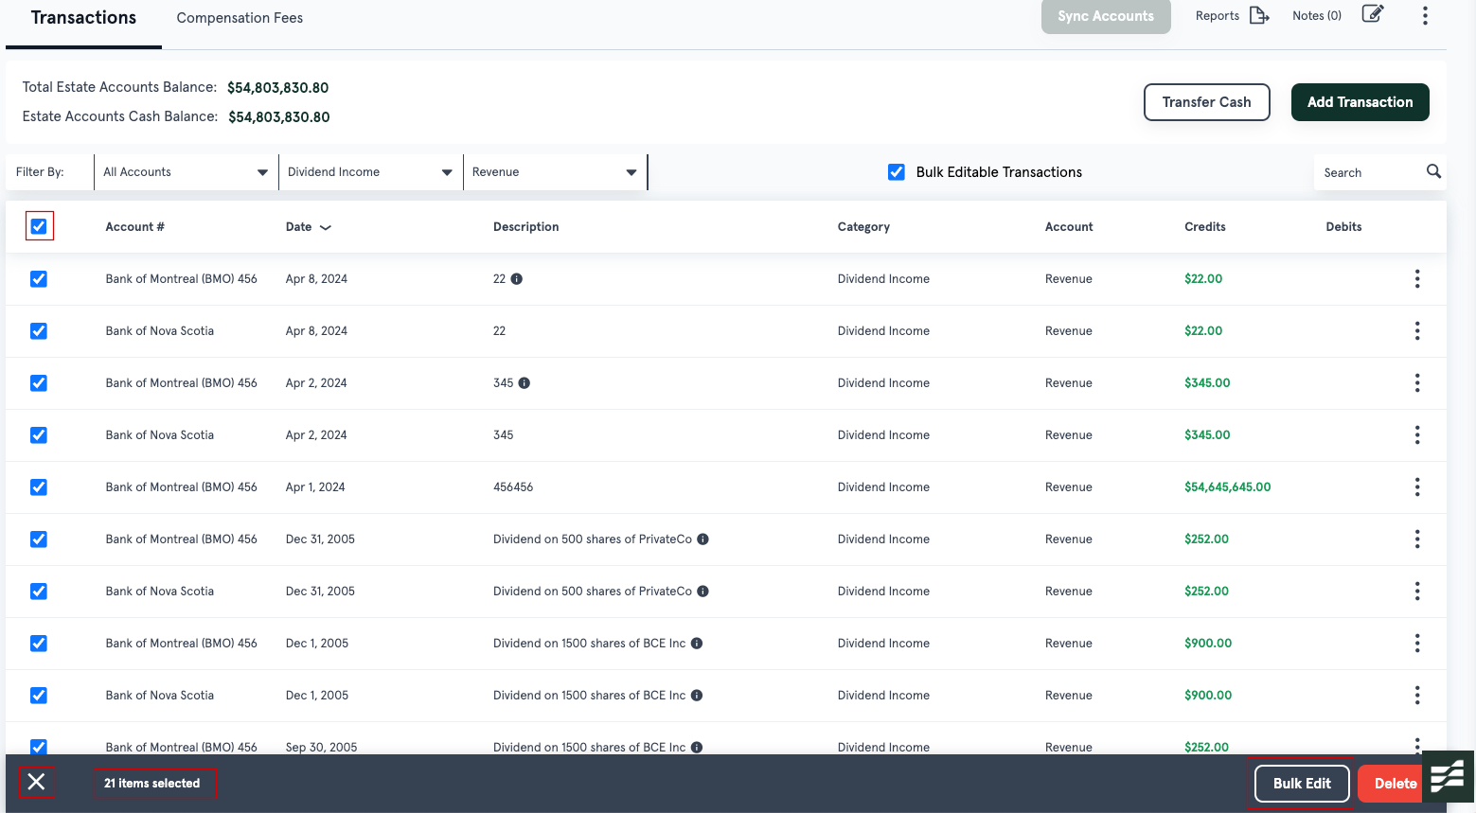

Bulk Edit Transaction Window

Once you have selected items to be bulk edited, the Bulk Edit Transaction window will appear. A warning message will appear indicating that you are about to make changes to ## of transaction.

Note: Once the changes have been made, they cannot be reversed and only fields where you have made changes will have those changed applied to all transactions.

All input fields excluding re-categorization.

The following input fields can be bulk edited. Note: re-categorization will be explained in 3. B below:

- Account – select an account from the drop down to change the account to apply the change to all transactions selected to be bulk edited.

- Date of Transaction – manually enter a date (YYYY-MM-DD) or select a date from the calendar icon to change the date of the transaction for all transactions selected to be bulk edited.

- Transaction Name – enter a transaction name for all transactions selected to be bulk edited.

- Account Type – select Capital or Revenue from the dropdown to change the account type for all transactions selected to be bulk edited.

- Notes – add a note to provide additional details for all transactions selected to be bulk edited.

- Exclude from executor compensation checkbox – by checking the exclude from executor compensation checkbox, this checkbox will be checked on all transaction records.

When you make changes to any of the above input fields, you will be presented with the following modal message. Click cancel to go back to the Bulk Edit Transactions window or click Proceed to make the changes.

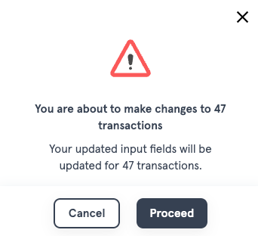

Re-categorize Transactions.

To re-categorize any transaction that has a category or is uncategorized, complete the following:

- Do you want to re-categorize transactions? - Select Yes

- Cashflow Type – You must select a cashflow type to re-categorize a transaction by selecting either Deposit or Withdrawal. By doing so, it will display the correct Categories dependent on if Deposit or Withdrawal are selected.

- Category – Select a new category to be applied to all transactions selected to be bulk edited.

- Click Save – when you click on Save, you will be presented with a modal message. The modal message will calculate the number of Cashflow type items that match your selection i.e. in this case 37 deposit items. It will also indicate that 10 out of the 47 transactions will not be updated as they have a cashflow type of withdrawal. Note: If you click Cancel you will return to the Bulk Edit Transactions window.

- Click Proceed – when you click on Proceed, the 37 transactions in this example will be re-categorized. Note: If you click Cancel you will return to the Bulk Edit Transactions window.

